
Kolbe Catholic College

YEAR 12 CHEMISTRY EXAMINATION

SEMESTER TWO 2002

STUDENT NAME: __________________________________________

TIME ALLOWED FOR THIS PAPER

Reading time before commencing work: Ten minutes
Working time for paper: Three hours

MATERIAL REQUIRED/RECOMMENDED FOR THIS PAPER

TO BE PROVIDED BY THE SUPERVISOR

This Question/Answer Booklet
Separate Multiple Choice Answer Sheet
Chemistry Data Sheet (inside front cover of this Question/Answer Booklet)

TO BE PROVIDED BY THE CANDIDATE

Standard Items: Pens, pencils, eraser or correction fluid, ruler

Special Items: A 2B, B or HB pencil for the separate Multiple Choice Answer Sheet and calculators satisfying the conditions set by the Curriculum Council.

IMPORTANT NOTE TO CANDIDATES

No other items may be taken into the examination room.

It is your responsibility to ensure that you do not have any unauthorised notes or other items of a non-personal nature in the examination room. If you have any unauthorised material with you, hand it to the supervisor BEFORE reading any further.

STRUCTURE OF THE PAPER
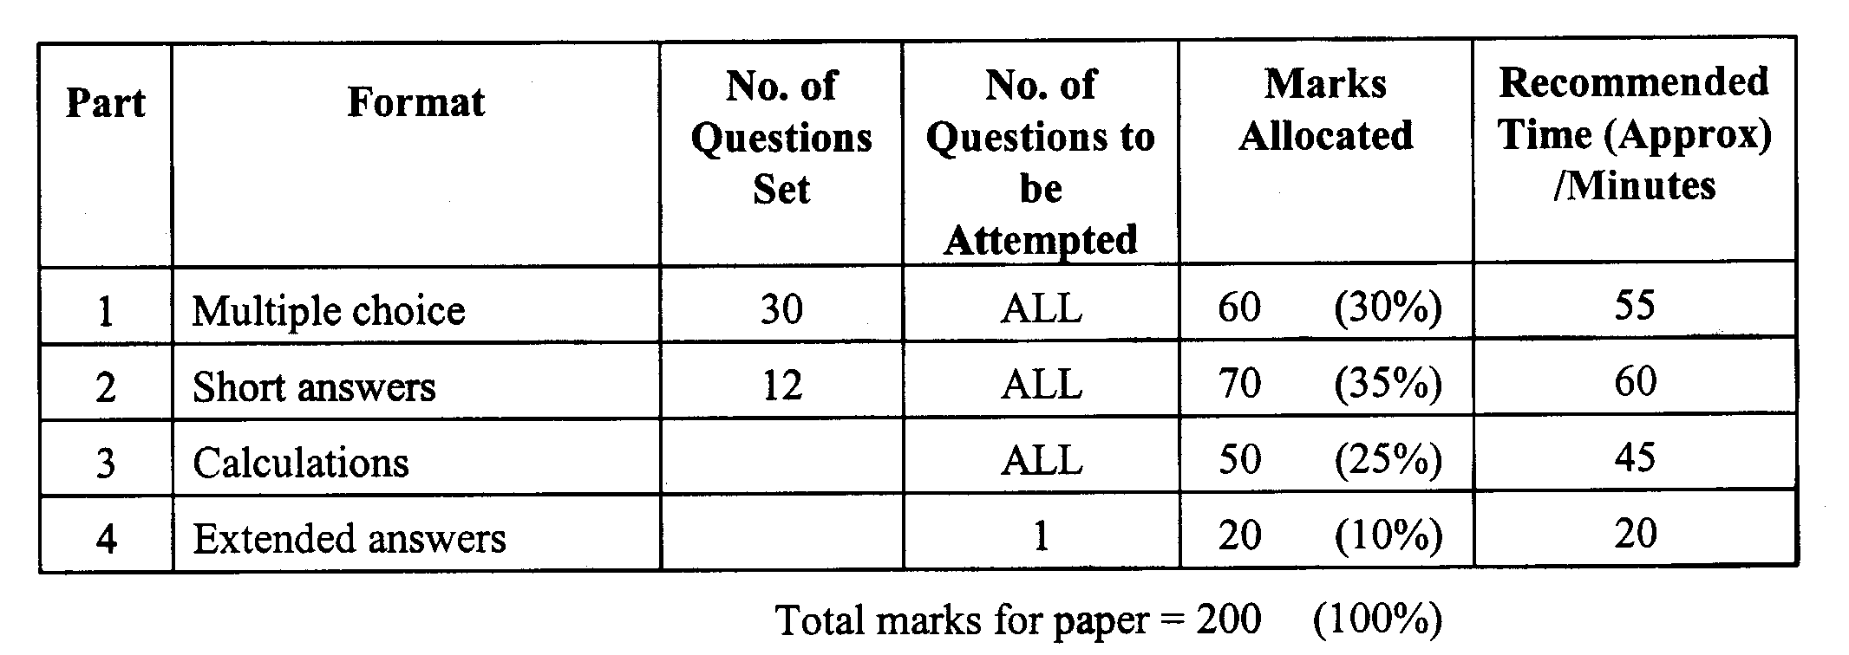
6
2
9
5

INSTRUCTIONS TO CANDIDATES

Reading Time: The examiners recommend that candidates spend the reading time mainly reading the Instructions to Candidates and Parts 2, 3 and 4.

Part 1: Multiple Choice

Answer ALL questions, using a 2B, B or HB pencil, on the separate Multiple Choice Answer Sheet. Do NOT use a ball point or ink pen.

If you consider that two or more of the alternative responses are correct, choose the one you think is best. If you think you know an answer, mark it even if you are not certain you are correct. Marks will not be deducted for incorrect answers.

FEEL FREE TO WRITE OR DO WORKING ON THE QUESTION PAPER; many students who score high marks in the Multiple Choice Section do this.

Parts 2, 3 and 4

Use a ball point or ink pen. Do not answer in pencil. Write your answers in this Question/Answer Booklet.

At the end of the examination, check that your Name has been placed in the spaces provided on the front cover of this Question/Answer Booklet and on your separate Multiple Choice Answer Sheet.

Questions containing specific instructions to show working should be answered with a complete logical, clear sequence of reasoning showing how the final answer was arrived at; correct answers which do not show working will not be awarded full marks.

CHEMICAL EQUATIONS

For full marks, chemical equations should refer only to those species consumed in the reaction and the new species produced. These species may be ions [for example Ag⁺(aq)], molecules [for example NH₃(g), NH₃(aq), CH₃COOH (l), CH₃COOH (aq)] or solids [for example BaSO₄(s), Cu(s), Na₂CO₃(s)].

PART 1 (60 marks = 30% of paper)

Answer ALL questions in Part 1 on the Separate Multiple Choice Answer Sheet provided, use a 2B, B or HB pencil. Each question in this part is worth 2 marks.
_____________________________________________________________________

1. 100 mL of 2.00 mol L⁻¹ sodium hydroxide is mixed with 50.0 mL of 2.50 mol L⁻¹ sodium hydroxide, then 50.0 mL of distilled water is added to the solution.
What is the concentration of the final sodium hydroxide solution produced?

a) 1.62 mol L⁻¹
b) 2.17 mol L⁻¹
c) 2.25 mol L⁻¹
d) 2.40 mol L⁻¹

2. Consider the following two solutions:

Solution 1 consists of 1 mol L⁻¹ iron (III) sulfate and Solution 2 consists of 1 mol L⁻¹ sodium sulfate.

Which of the following statements is TRUE?

a) The [SO₄²⁻] in Solution 1 is 1.5 times the [SO₄²⁻] in Solution 2.
b) The [Na⁺] is Solution 2 is equal to the [Fe³⁺] in Solution 1.
c) The [Na⁺] in Solution 2 is half the [SO₄²⁻] in Solution 1.
d) The [Fe³⁺] in Solution 1 is equal to the [SO₄²⁻] in Solution 2.

3. Which one of the following pairs of substances, when mixed, would produce a pink precipitate?

a) Silver nitrate and sodium bromide.
b) Manganese nitrate and sodium carbonate.
c) Calcium chloride and sodium carbonate.
d) Barium chloride and ammonium sulfate.

4. What is the concentration of a solution prepared by dissolving 10.7 g of ammonium chloride in 250 mL of water?

a) 0.2 mol L⁻¹
b) 0.25 mol L⁻¹
c) 0.6 mol L⁻¹
d) 0.8 mol L⁻¹

5. An element has the following ground state electron configuration: 1s² 2s² 2p⁵

How many ‘valence’ electrons does this atom have?

a) 1
b) 2
c) 5
d) 7

6. The first four successive ionisation energies for element X are

0.637 MJ mol⁻¹ 1.24 MJ mol⁻¹ 2.40 MJ mol⁻¹ 7.10 MJ mol⁻¹

Which of the following formulae is most likely for the chloride of element X?

a) XCl
b) XCl₂
c) XCl₃
d) XCl₄

7. Which one of the following at 25ºC is a good conductor of electricity?

a) 1,2-dichloroethane ClCH₂CH₂Cl(l)
b) A water solution of sodium trichloroethanoate
c) tellurium(II) chloride, TeCl₂(s)
d) tin(IV) chloride, SnCl₄(l)

8. An element X has ions XO₃²⁻ and XO₄²⁻. Which one of the following is X?

a) chlorine
b) nitrogen
c) phosphorus
d) sulfur

9. Which one of the following does not consist of planar molecules?

a) benzene
b) boron trichloride
c) methanal
d) propene

SEE NEXT PAGE

10. Consider the following equilibrium:

CH₃COOH(aq) + H₂O(l) CH₃COO⁻(aq) + H₃O⁺(aq) + heat

A stress was applied at time t₁ and the data was plotted on the following graph:

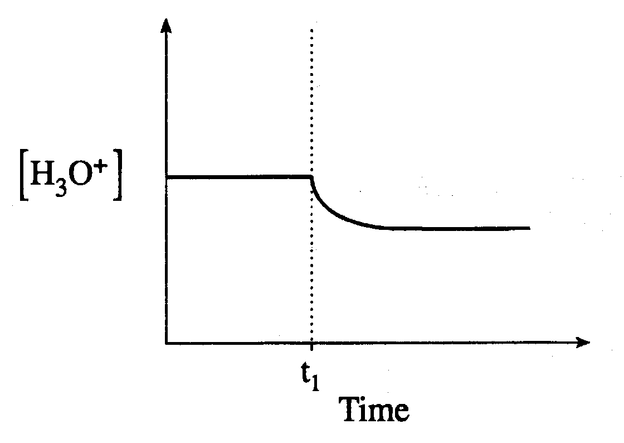
The stress that was imposed at time t₁ is the result of

a) the addition of HCl
b) decreasing the temperature
c) the addition of NaCH₃COO
d) increasing the volume of the container

11. Water will act as an acid with which of the following?

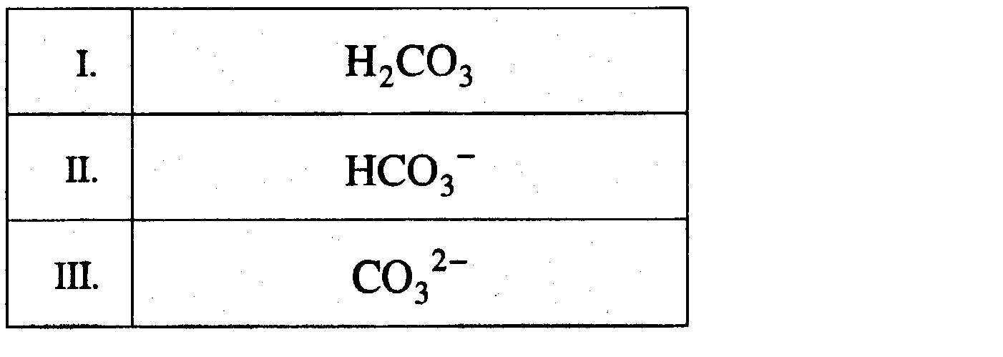

a) I only
b) III only
c) I and II only
d) II and III only

12. An acid is added to water and a new equilibrium is established. The new equilibrium can be described by

a) pH < pOH and K_{w} = 1 x 10⁻¹⁴
b) pH < pOH and K_{w} < 1 x 10⁻¹⁴
c) pH > pOH and K_{w} = 1 x 10⁻¹⁴
d) pH > pOH and K_{w} > 1 x 10⁻¹⁴

13. When the [H₃O⁺] in a solution is increased to twice the original concentration, the change in pH could be from

a) 1.7 to 1.4
b) 2.0 to 4.0
c) 5.0 to 2.5
d) 8.5 to 6.5

14. Which one of the following 1.0 M solutions would have a pH greater than 7.00?

a) HCN
b) KNO₃
c) NH₄Cl
d) NaCH₃COO

15. Which of the following represents a redox reaction?

a) CaCO₃ ---------> CaO + CO₂
b) SiCl₄ + 2Mg ---------> Si + 2MgCl₂
c) 2NaOH + H₂SO₄ ---------> 2H₂O + Na₂SO₄
d) AgBr + 2S₂O₃²⁻ ---------> Ag(S₂O₃)₂³⁻ + Br ⁻

16. Consider the following reaction:

TiCl₄ + O₂ ---------> TiO₂ + 2Cl₂

Each oxygen is

a) reduced and loses 2e –
b) reduced and gains 2e –
c) oxidised and loses 2e –
d) oxidised and gains 2e –

17. When NO₂ acts as a reducing agent, a possible product is

a) NO
b) N₂
c) NO₃⁻
d) None of the above

18. Which of the following 1.0 M solutions will react spontaneously with lead?

a) KCl
b) CuCl₂
c) ZnCl₂
d) MgCl₂

19. Consider the following redox reaction:

I₂ + 2S₂O₃²⁻ ---------> S₄O₆²⁻ + 2I –

In a titration, 40.00 mL of Na₂S₂O₃ is needed to react completely with 4.0 x 10⁻³ mol I₂. What is the concentration of Na₂S₂O₃ ?

a) 0.10M
b) 0.16M
c) 0.20M
d) 0.32M

Use the following diagram to answer questions 20 and 21.

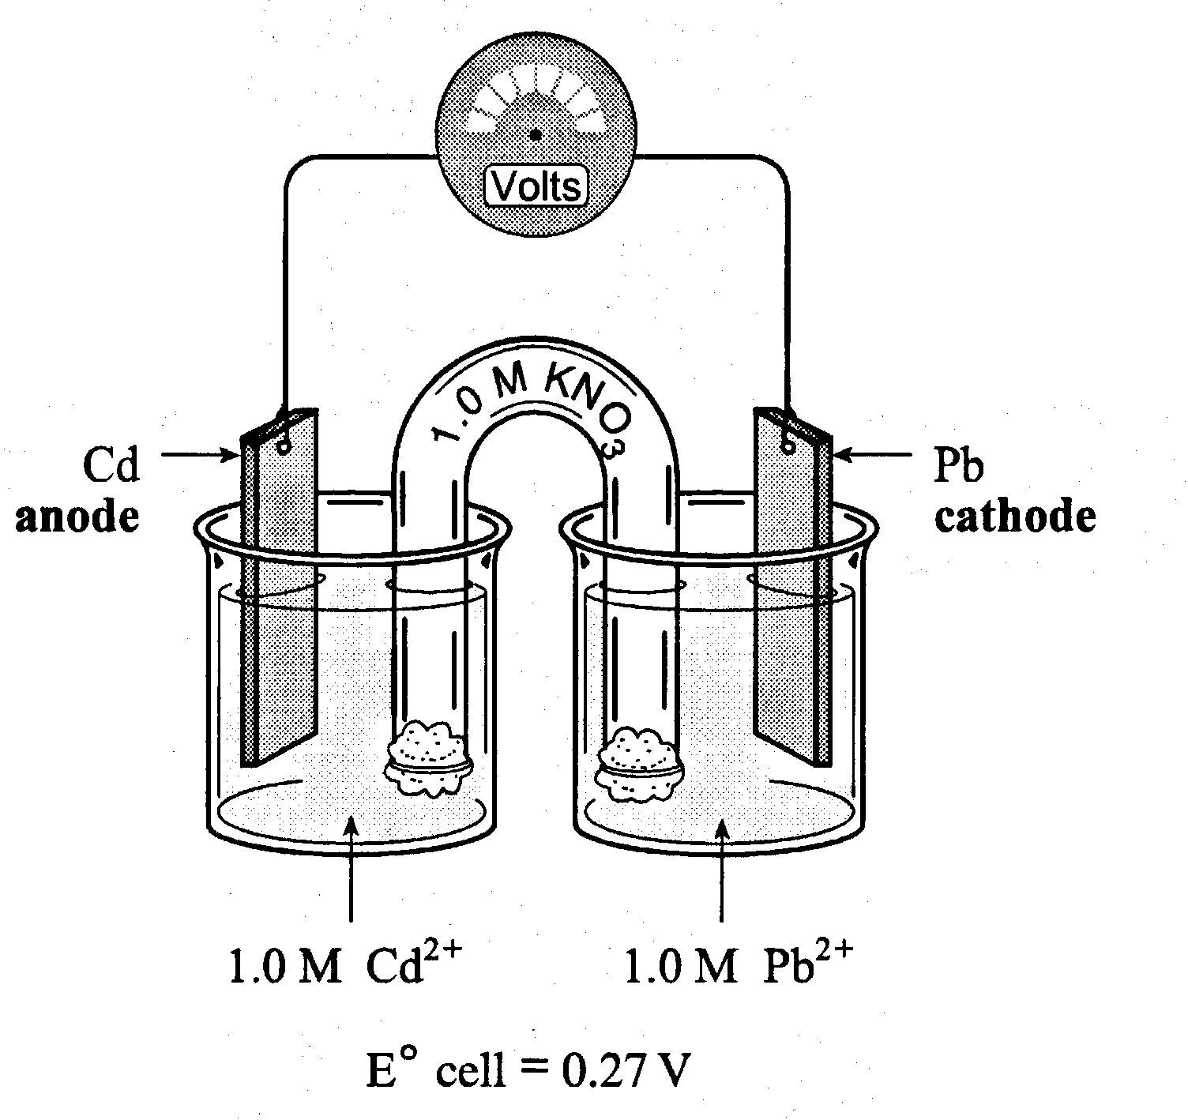

20. As the cell operates, electrons flow toward

a) the Pb electrode, where Pb is oxidised
b) the Cd electrode, where Cd is oxidised
c) the Pb electrode, where Pb²⁺ is reduced
d) the Cd electrode, where Cd²⁺ is reduced

21. The Eº value for the reduction of Cd²⁺ is

a) -0.40 V
b) -0.27 V
c) +0.14 V
d) +0.40 V

22. The following reaction occurs in an electrochemical cell:

3Cu²⁺ + 2Cr ---------> 2Cr³⁺ + 3Cu

The Eº for the cell is

a) 0.40 V
b) 0.75 V
c) 1.07 V
d) 2.50 V

23. A molten salt, ZnCl₂, undergoes electrolysis. The cathode reaction is

a) Zn ---------> Zn²⁺ + 2e⁻
b) 2Cl⁻ ---------> Cl₂ + 2e⁻
c) Cl₂ + 2e⁻ ---------> 2Cl⁻
d) Zn²⁺ + 2e⁻ ---------> Zn

24. At 500ºC sulfur vapour reacts with hydrogen gas as follows

S₈(g) + 8H₂(g) ---------> 8H₂S(g)

When 1.0 L of sulfur vapour (at 500ºC and 1.00 atm) reacts with excess hydrogen gas what volume of hydrogen sulfide (measured at 500ºC and 1.00 atm) is produced?

a) 1.0 L
b) 8.0 L
c) 9.0 L
d) 17.0 L

25. Which of the following lists shows the four substances in the correct ascending order of their boiling points?

a) He, CH₃CH₂OH, Cl₂, CH₃OH
b) Cl₂, CH₃CH₂OH, He, CH₃OH
c) He, Cl₂, CH₃OH, CH₃CH₂OH
d) Cl₂, He, CH₃CH₂OH, CH₃OH

26. Propanoic acid reacts with 1-butanol in the presence of sulfuric acid catalyst. Which of the following is a correct organic product of the above reaction?

a) CH₃(CH₂)₆SO₄
b) CH₃CH₂COO(CH₂)₃CH₃
c) HCOO(CH₂)₅CH₃
d) CH₃(CH₂)₄COCH₃

27. The repeating section of a condensation polymer is represented below:

--O(CH₂)₃OCOCOO--

Which of the following pairs of monomers is most likely to produced the above section of polymer?

a) CH₃(CH₂)₂COOH and CH₃CH₂OH
b) HO(CH₂)₃OH and HOOCCOOH
c) HO(CH₂)₃OH and HOOC(CH₂)₂COOH
d) CH₃COCH₃ and CH₃(CH₂)₃CO(CH₂)₂CH₃

28. Which of the following statements about molecules is incorrect?

a) A molecule which has polar bonds within it is not necessarily a polar molecule.
b) Pairs of electrons in the outer shell of a covalently bonded atom repel as far away as possible.
c) The molecules CH₄ and CCl₄ are polar but CHCl₃ and CH₃Cl molecules are non-polar.
d) Oxygen atoms in molecules generally have two bond pairs of electrons and two lone pairs of electrons.

29. Element X is a transition metal. Which of the following properties of X most specifically identifies it as a transition metal?

a) X has common oxidation numbers of +3, +6 and +2.
b) X has a shiny silvery appearance when its surface is freshly cut.
c) X forms X³⁺ ions and is an amphoteric metal.
d) X is a good conductor of electricity in both the solid and molten phases.

30. A current of 2.00 A was passed for one minute through each of the following 1.0 mol L⁻¹ solutions using inert electrodes:

Ni²⁺(aq), Pb²⁺(aq), Ag⁺(aq), Au³⁺(aq).

In which one did the greatest mass of metal deposit at the cathode?

a) Ni²⁺(aq)
b) Pb²⁺(aq)
c) Ag⁺(aq)
d) Au³⁺(aq)

END OF PART 1

PART 2 (70 marks = 35% of paper)

Answer ALL questions in Part 2 in the spaces provided below.
_____________________________________________________________________

Give fully balanced equations for the reactions which occur (if at all) in the following experiments. Use ionic equations where appropriate. In each case describe observations such as colour changes, precipitate formation (give the colour), or gas evolution (give the colour or describe as colourless) resulting from the chemical reaction.

1. (a) Propanal is shaken vigorously with a dilute solution of acidified potassium permanganate.

Oxidation

Reduction

Overall Equation

Observation

[4 marks]

(b) Concentrated ammonia solution is added to solid zinc hydroxide.

Equation

Observation

[3 marks]
(c) Magnesium metal is placed in a solution of lead(II) nitrate.

Equation

Observation

[3 marks]

SEE NEXT PAGE

(d) A solution of ammonium carbonate is added to a solution of potassium
hydroxide and the mixture is then gently warmed.

Equation

Observation

[3 marks]

2. For each of the species listed in the table below;

(a) Draw the structural formula, including all valence shell electron pairs and representing each either as : or as - . . – . .
[for example, water H : O : H or H – O – H or H – O – H and so on].
. . – . .
(b) Indicate the shape of each species by either a sketch or a name.
(c) Indicate the polarity of each species. Write either ‘non-polar’ or ‘polar’.

Species | Structural formula  (showing all valence shell electrons) | Shape  (sketch or name) | Polarity  (‘non-polar’ or  ‘polar’)
Carbonate ion

Chlorite ion
(ClO₂⁻)

Ethyne

[12 marks]

3. (a) Write the name of an addition polymer .

_______________________________________________________________________
[1 mark]

(b) Write the name and draw the structure of the monomer used to produce (a)

Name ______________________ Structure:

[3 marks]

- Below is a diagram of an electrochemical cell.

(a) Write a half equation to show the reaction at the anode of the cell.

________________________________________________________________________
[2 marks]

(b) Draw an arrow in the box provided on the diagram to indicate the flow of electrons
in the external circuit. [1 mark]

(c) Give the formula of one ion that will move from the Mg/Mg2+ half cell
towards the Ag/Ag+ half cell through the salt bridge.

________________________________________________________________________
[1 mark]

5. Complete the following table.

I.U.P.A.C. NAME |  | SEMI-STRUCTURAL FORMULA
(a) 2-iodo-3-methyl-2-pentanol

(b) 5,6-difluoro-5-methyl-3-heptanone

(c)…………………………………………………..… | CH3CH2CH2CH2ONa
(d)……………………………………………………….… | HCOOCH2CH2CH2CH2CH3

[4 marks]

6. When carbon dioxide and chlorine gas are mixed a slow reaction takes place.

2CO2(g) + 2Cl2(g) 2COCl2(g) + O2(g) ∆H = -52 kJ mol-1

"The above mixture of gases will eventually reach chemical equilibrium in
a closed system".

(a) With reference to the above, explain what is meant by:

i) Chemical equilibrium _____________________________________________________

_________________________________________________________________________

__________________________________________________________________[2 marks]

ii) ΔH __________________________________________________________________

_________________________________________________________________________

__________________________________________________________________[2 marks]

SEE NEXT PAGE

(b) If each of the following changes is imposed separately on the system (on the previous page) at equilibrium, state what will happen to the amount of products and reactants as the new equilibrium is re-established. Use the words "increase", "decrease" or "remain constant". Give a reason for your answer in each case.

(i) Pressure is increased by reducing the volume of the container:

Amount of products will ___________________________________________________

Amount of reactants will ___________________________________________________
Reason: ________________________________________________________________

________________________________________________________________________

[4 marks]

(ii) Temperature is decreased:

Amount of products will ___________________________________________________

Amount of reactants will ___________________________________________________

Reason: ________________________________________________________________

[4 marks]
7. Consider the following list of substances:

sulfur trioxide gas, ammonia gas, ethanol, butanoic acid, carbon disulfide, propanone.

From the above, choose the substance(s) relevant to each of the following descriptions.
Note: The same substance may appear more than once in your answers to this question.

(a) The substance whose molecules are linear and non-polar

________________________________________________________________________

(b) The substance which when dissolved in water produces a strong acid

________________________________________________________________________
(c) The two substances required to make an ester

______________________________ and ______________________________________

(d) The substance least soluble in water

______________________________________________________________________
(e) The three substances which are non-electrolytes

___________________ and ______________________ and _______________________
[8 marks]

8. Write a chemical equation(s) which is consistent with the observations in the following experiments:

What is done | Observation | Equation(s)
A colourless liquid is added dropwise to a colourless liquid. | A brown precipitate is formed at first, but the precipitate dissolves to become colourless with further addition of the first liquid.
A colourless liquid is added to a green solid. | Bubbles of a colourless odourless gas are evolved and the green solid dissolves to form a clear green liquid.
A colourless liquid is added to a pink/red shiny solid. | A brown gas is evolved and a clear blue liquid is formed.
[6 marks]
9. In the table below, draw structural diagrams for the indicated substances:

A tertiary alcohol whose formula is C₅H₁₂O

The cis- isomer of
C₄ H₆Cl₂

The organic product formed
when sodium metal is added to
methanol

[7 marks]

END OF PART 2

PART 3 (50 marks = 25% of paper)

Answer ALL questions in Part 3. The calculations are to be set out in detail in this Question/Answer Booklet. Marks will be allocated for correct equations and clear setting out, even if you cannot complete the problem. When questions are divided into sections, clearly distinguish each section using (a), (b), and so on. Express your final numerical answers to three (3) significant figures where appropriate, and provide units where applicable. Information which may be necessary for solving the problems is located on the separate Chemistry Data Sheet. Show clear reasoning: if you don’t, you will lose marks.
_____________________________________________________________________

1. A sample of 3.230 g of an unsaturated chlorofluorocarbon (a compound containing carbon, fluorine and chlorine only) was analysed as follows:

All the carbon in the sample was converted into carbon dioxide gas, which was then bubbled through excess limewater. Highly insoluble calcium carbonate weighing 4.864 g was produced.

A further sample of the chlorofluorocarbon weighing 3.230 g was vaporised in the absence of air and produced 545 mL of vapour at STP.

A third sample of the compound was analysed and was found to contain 28.6% by mass fluorine.

a) Determine the empirical formula of the compound. [6 marks]

b) Determine the molecular formula of the compound. [2 marks]

c) Name and draw a possible structure of the compound. [2 marks]

_________________________________________________________________________________

_________________________________________________________________________________

_________________________________________________________________________________

_________________________________________________________________________________

_________________________________________________________________________________

_________________________________________________________________________________

_________________________________________________________________________________

_________________________________________________________________________________

_________________________________________________________________________________

_________________________________________________________________________________

_________________________________________________________________________________

_________________________________________________________________________________

_________________________________________________________________________________

_________________________________________________________________________________

_________________________________________________________________________________

_________________________________________________________________________________

_________________________________________________________________________________

_________________________________________________________________________________

_________________________________________________________________________________

_________________________________________________________________________________

_________________________________________________________________________________

_________________________________________________________________________________

_________________________________________________________________________________

_________________________________________________________________________________

_________________________________________________________________________________

_________________________________________________________________________________

_________________________________________________________________________________

_________________________________________________________________________________

_________________________________________________________________________________

_________________________________________________________________________________

_________________________________________________________________________________

_________________________________________________________________________________

_________________________________________________________________________________

_________________________________________________________________________________

_________________________________________________________________________________

_________________________________________________________________________________

_________________________________________________________________________________

_________________________________________________________________________________

2. An analytical chemist was contracted by a mining company to determine the percentage of nickel in an ore which was known to be mainly hydrated nickel(II) carbonate of formula NiCO₃.xH₂O. [Assume that the impurities in the ore are inert and do not react chemically in any testing procedure.]
The chemist took a 5.750 g sample of the ore and heated it strongly to drive off all the water of crystallisation. The dry anhydrous powder (nickel carbonate + impurities) remaining weighed 4.164 g. This powder was then dissolved in excess nitric acid. The resulting solution was then diluted to 1.00 L by the addition of distilled water, and was then electrolysed with inert electrodes until the mass of the cathode finally remained constant, indicating that all the nickel in the solution had been deposited at the cathode. The gain in mass of the cathode was 1.707 g.
From the above information, calculate:
(a) the value of x (ie determine the formula of the hydrated nickel carbonate).
(b) the percentage of hydrated nickel carbonate in the ore.
[10 marks]

_________________________________________________________________________________

_________________________________________________________________________________

_________________________________________________________________________________

_________________________________________________________________________________

_________________________________________________________________________________

_________________________________________________________________________________

_________________________________________________________________________________

_________________________________________________________________________________

_________________________________________________________________________________

_________________________________________________________________________________

_________________________________________________________________________________

_________________________________________________________________________________

_________________________________________________________________________________

_________________________________________________________________________________

_________________________________________________________________________________

_________________________________________________________________________________

_________________________________________________________________________________

_________________________________________________________________________________

_________________________________________________________________________________

_________________________________________________________________________________

_________________________________________________________________________________

_________________________________________________________________________________

_________________________________________________________________________________

_________________________________________________________________________________

_________________________________________________________________________________

_________________________________________________________________________________

_________________________________________________________________________________

_________________________________________________________________________________

_________________________________________________________________________________

_________________________________________________________________________________

_________________________________________________________________________________

_________________________________________________________________________________

_________________________________________________________________________________

_________________________________________________________________________________

_________________________________________________________________________________

_________________________________________________________________________________

_________________________________________________________________________________

_________________________________________________________________________________

_________________________________________________________________________________

_________________________________________________________________________________

_________________________________________________________________________________

_________________________________________________________________________________

_________________________________________________________________________________

_________________________________________________________________________________

_________________________________________________________________________________

- One method of measuring the blood alcohol content (BAC) of a human is the Kozelka and Hine procedure. In this method, protein, aldehydes and ketones are first removed from a blood sample and the purified sample is then reacted with an acidified dichromate solution.
A 25.0 mL sample of blood taken from a driver involved in an accident yielded sufficient alcohol (ethanol) to consume 3.00 x 10⁻⁵ moles of Cr₂O₇²⁻(aq) according to the equation:

2Cr₂O₇²⁻(aq) + 3CH₃CH₂OH(aq) + 16H⁺(aq) → 4Cr³⁺(aq) + 3CH₃COOH(aq) + 11H₂O(l).

- calculate the BAC of the driver expressed in millimoles of ethanol per 100 mL of
blood. [Note: 1 millimole = 10⁻³ mole.] [6 marks]

(b) Assuming that 1.00 mL of blood weighs 1.00 g, calculate the percentage by mass of ethanol in the driver’s blood. [4 marks]

_________________________________________________________________________________

_________________________________________________________________________________

_________________________________________________________________________________

_________________________________________________________________________________

_________________________________________________________________________________

_________________________________________________________________________________

_________________________________________________________________________________

_________________________________________________________________________________

_________________________________________________________________________________

_________________________________________________________________________________

_________________________________________________________________________________

_________________________________________________________________________________

_________________________________________________________________________________

_________________________________________________________________________________

_________________________________________________________________________________

_________________________________________________________________________________

_________________________________________________________________________________

_________________________________________________________________________________

_________________________________________________________________________________

_________________________________________________________________________________

_________________________________________________________________________________

_________________________________________________________________________________

_________________________________________________________________________________

_________________________________________________________________________________

_________________________________________________________________________________

_________________________________________________________________________________

_________________________________________________________________________________

_________________________________________________________________________________

_________________________________________________________________________________

_________________________________________________________________________________

_________________________________________________________________________________

_________________________________________________________________________________

_________________________________________________________________________________

_________________________________________________________________________________

_________________________________________________________________________________

_________________________________________________________________________________

_________________________________________________________________________________

_________________________________________________________________________________

_________________________________________________________________________________

_________________________________________________________________________________

_________________________________________________________________________________

_________________________________________________________________________________

_________________________________________________________________________________

_________________________________________________________________________________

_________________________________________________________________________________

_________________________________________________________________________________

- The acidity of wine is due to the grape acid tartaric acid HOOCCHOHCHOHCOOH(aq).
A wine producer wishes to determine the percentage of tartaric acid in a sample of wine.
Tartaric acid is a weak diprotic acid which ionizes according to the following equation:

HOOCCHOHCHOHCOOH (aq) → ⁻OOCCHOHCHOHCOO ⁻(aq) + 2H⁺(aq).

She takes a 20.0 mL sample of the wine and dilutes it to 250 mL in a volumetric flask.
The diluted wine is then placed in a burette and is titrated against 20.0 mL samples of a standardized 0.0125 mol L⁻¹ sodium hydroxide solution in a conical flask to which a suitable indicator has been added.
The results of four titrations of the diluted wine are shown in the following table:

 | Titration 1 | Titration 2 | Titration 3 | Titration 4
Initial volume (mL) | 0.0 | 0.5 | 1.2 | 0.0
Final volume (mL) | 13.5 | 12.5 | 13.1 | 12.1
Titre volume (mL)

- Determine the appropriate average titre of diluted wine in this experiment.
[2 marks]
- Calculate the concentration of tartaric acid in the undiluted wine in mol L⁻¹.
[6 marks]
- Calculate the percentage by mass of tartaric acid in the wine given that
1.00 mL of the wine weighs 1.00 g. [2 marks]
_________________________________________________________________________________

_________________________________________________________________________________

_________________________________________________________________________________

_________________________________________________________________________________

_________________________________________________________________________________

_________________________________________________________________________________

_________________________________________________________________________________

_________________________________________________________________________________

_________________________________________________________________________________

_________________________________________________________________________________

_________________________________________________________________________________

_________________________________________________________________________________

_________________________________________________________________________________

_________________________________________________________________________________

_________________________________________________________________________________

_________________________________________________________________________________

_________________________________________________________________________________

_________________________________________________________________________________

_________________________________________________________________________________

_________________________________________________________________________________

_________________________________________________________________________________

_________________________________________________________________________________

_________________________________________________________________________________

_________________________________________________________________________________

_________________________________________________________________________________

_________________________________________________________________________________

_________________________________________________________________________________

_________________________________________________________________________________

_________________________________________________________________________________

_________________________________________________________________________________

_________________________________________________________________________________

_________________________________________________________________________________

_________________________________________________________________________________

_________________________________________________________________________________

_________________________________________________________________________________

_________________________________________________________________________________

_________________________________________________________________________________

_________________________________________________________________________________

_________________________________________________________________________________

- The explosive TNT [2,4,6 trinitrotoluene (2,4,6 trinitro-1-methylbenzene)] is made by treating methyl benzene (toluene, C₆H₅CH₃) with nitric acid. Three alternate H atoms on the toluene ring are replaced by NO₂ groups producing TNT whose overall molecular formula may be written C₇H₅N₃O₆.

(a) Sketch the structure of TNT. [2 marks]

- Calculate the masses of methyl benzene and nitric acid required to manufacture
1.00 tonne of TNT. [Note: 1 tonne = 10⁶ g.] [8 marks]

_________________________________________________________________________________

_________________________________________________________________________________

_________________________________________________________________________________

_________________________________________________________________________________

_________________________________________________________________________________

_________________________________________________________________________________

_________________________________________________________________________________

_________________________________________________________________________________

_________________________________________________________________________________

_________________________________________________________________________________

_________________________________________________________________________________

_________________________________________________________________________________

_________________________________________________________________________________

_________________________________________________________________________________

_________________________________________________________________________________

_________________________________________________________________________________

_________________________________________________________________________________

_________________________________________________________________________________

_________________________________________________________________________________

_________________________________________________________________________________

_________________________________________________________________________________

_________________________________________________________________________________

_________________________________________________________________________________

_________________________________________________________________________________

_________________________________________________________________________________

_________________________________________________________________________________

_________________________________________________________________________________

_________________________________________________________________________________

_________________________________________________________________________________

_________________________________________________________________________________

_________________________________________________________________________________

_________________________________________________________________________________

_________________________________________________________________________________

_________________________________________________________________________________

_________________________________________________________________________________

_________________________________________________________________________________

_________________________________________________________________________________

_________________________________________________________________________________

_________________________________________________________________________________

_________________________________________________________________________________

_________________________________________________________________________________

_________________________________________________________________________________

_________________________________________________________________________________

_________________________________________________________________________________

_________________________________________________________________________________

_________________________________________________________________________________

_________________________________________________________________________________

_________________________________________________________________________________

PART 4 (20 marks = 10% of paper)

Answer ONE of the following extended answer questions. Where applicable use equations, diagrams and illustrative examples of the chemistry you are describing.

Marks are awarded principally for the relevant chemical content of your essay, but you will lose marks if what you write is unclear or lacks coherence. Your answer should be presented in about 1.5 - 2 pages. Begin your essay on page 28.
_________________________________________________________________________________

1. Ammonia is one of the most widely used chemicals in the world. It is synthesized from its elements nitrogen and hydrogen. Ammonia is used in making ammonium nitrate fertilizer when NH₃(aq) is neutralized by nitric acid. Ammonia forms only a weak base when dissolved in water even though it is highly soluble in water – one volume of water at 25ºC is able to dissolve about 700 volumes of ammonia gas at the same temperature and at 1.00 atmospheres pressure.
Compare and contrast this information about the manufacture, solubility and uses of ammonia with the manufacture and uses of hydrogen chloride gas.
Include in your answer an explanation of the difference in the strength of aqueous solutions of ammonia to behave as a base and the strength of aqueous solutions of hydrogen chloride to act as an acid. [20 marks]

OR

2. A number of pure substances (elements and compounds) were subjected to several chemical and physical tests. The results of the tests are summarized in the following table.

Substance | Boiling Point (ºC) | Solubility in water | Conductivity when solid | Conductivity when molten | Nature of aqueous solution | Other properties
A | 650 | “soluble” | nil | nil | Non-electrolyte | brittle  white solid
B | 100 | “insoluble” | nil | nil | - | colourless  non-polar liquid
C | 1100 | “soluble” | nil | excellent | Strong electrolyte | brittle  white solid
D | 1800 | “insoluble” | excellent | excellent | - | silvery solid

Discuss the properties of each substance, relating each to a likely structure for the substance. Suggest the type of bonding likely to be found in each one and give reasons. Suggest a possible name for each substance. [20 marks]

_____________________________________________________________________

_____________________________________________________________________

_____________________________________________________________________

_____________________________________________________________________

_____________________________________________________________________

_____________________________________________________________________

_____________________________________________________________________

_____________________________________________________________________

_____________________________________________________________________

_____________________________________________________________________

_____________________________________________________________________

_____________________________________________________________________

_____________________________________________________________________

_____________________________________________________________________

_____________________________________________________________________

_____________________________________________________________________

_____________________________________________________________________

_____________________________________________________________________

_____________________________________________________________________

_____________________________________________________________________

_____________________________________________________________________

_____________________________________________________________________

_____________________________________________________________________

_____________________________________________________________________

_____________________________________________________________________

_____________________________________________________________________

_____________________________________________________________________

_____________________________________________________________________

_____________________________________________________________________

_____________________________________________________________________

_____________________________________________________________________

_____________________________________________________________________

_____________________________________________________________________

_____________________________________________________________________

_____________________________________________________________________

_____________________________________________________________________

_____________________________________________________________________

_____________________________________________________________________

_____________________________________________________________________

_____________________________________________________________________

_____________________________________________________________________

_____________________________________________________________________

_____________________________________________________________________

_____________________________________________________________________

_____________________________________________________________________

_____________________________________________________________________

_____________________________________________________________________

_____________________________________________________________________

_____________________________________________________________________

_____________________________________________________________________

_____________________________________________________________________

_____________________________________________________________________

_____________________________________________________________________

_____________________________________________________________________

_____________________________________________________________________

_____________________________________________________________________

_____________________________________________________________________

_____________________________________________________________________

_____________________________________________________________________

_____________________________________________________________________

_____________________________________________________________________

_____________________________________________________________________

_____________________________________________________________________

_____________________________________________________________________

_____________________________________________________________________

_____________________________________________________________________

_____________________________________________________________________

_____________________________________________________________________

_____________________________________________________________________

_____________________________________________________________________

_____________________________________________________________________

_____________________________________________________________________

_____________________________________________________________________

_____________________________________________________________________

_____________________________________________________________________

_____________________________________________________________________

_____________________________________________________________________

_____________________________________________________________________

_____________________________________________________________________

_____________________________________________________________________

_____________________________________________________________________

_____________________________________________________________________

_____________________________________________________________________

_____________________________________________________________________

_____________________________________________________________________

_____________________________________________________________________

_____________________________________________________________________

_____________________________________________________________________

_____________________________________________________________________

_____________________________________________________________________

_____________________________________________________________________

_____________________________________________________________________

_____________________________________________________________________

_____________________________________________________________________

_____________________________________________________________________

_____________________________________________________________________

_____________________________________________________________________

_____________________________________________________________________

_____________________________________________________________________

_____________________________________________________________________

_____________________________________________________________________

_____________________________________________________________________

_____________________________________________________________________

_____________________________________________________________________

_____________________________________________________________________

_____________________________________________________________________

_____________________________________________________________________

_____________________________________________________________________

_____________________________________________________________________

_____________________________________________________________________

_____________________________________________________________________

_____________________________________________________________________

_____________________________________________________________________

_____________________________________________________________________

_____________________________________________________________________

_____________________________________________________________________

_____________________________________________________________________

_____________________________________________________________________

_____________________________________________________________________

_____________________________________________________________________

_____________________________________________________________________

_____________________________________________________________________

_____________________________________________________________________

_____________________________________________________________________

_____________________________________________________________________

_____________________________________________________________________

_____________________________________________________________________

_____________________________________________________________________

_____________________________________________________________________

_____________________________________________________________________

_____________________________________________________________________

_____________________________________________________________________

_____________________________________________________________________

_____________________________________________________________________

_____________________________________________________________________

_____________________________________________________________________

END OF PAPER

